TRANSART BRINGS INTERNATIONAL ART, ARTISTS, AUTHORS & INSPIRATION TO SOUTH FLORIDA for our 6th YEAR, JANUARY 25-26, 2020 | THIS YEAR WE ARE COMING TO WILTON MANORS!

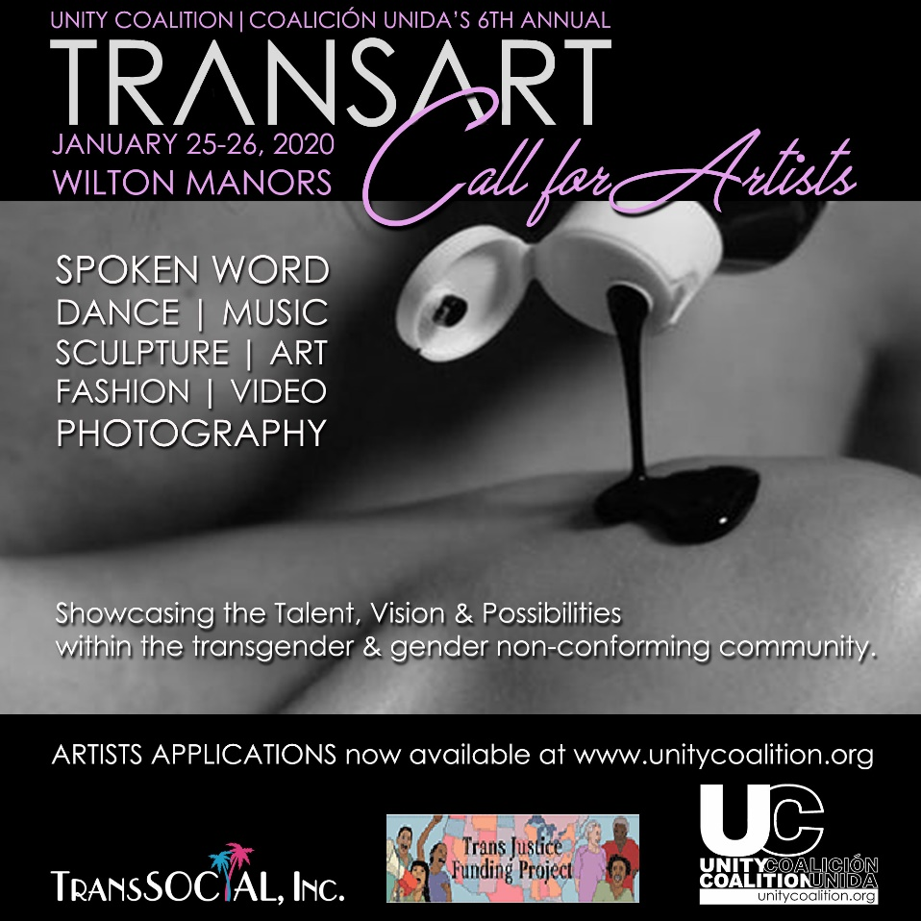
Showcasing the Talent, Vision and Possibilities within the transgender & gender non-conforming community, the annual TRANSART Artists Showcase & Conference brings together a collection of individuals & artistic genres to create awareness, nurture aspiring artists and enlighten the general population about the many layers of this community.
Celebrating its 6th successful year, TRANSART is produced by Unity Coalition|Coalición Unida (UC|CU), the First organization for the So. Fla. Latinx|Hispanic|LGBT community - advancing Equality & Fairness -through Education, Leadership and Awareness, since 2002. This year, we are bringing our TRANSART CONFERENCE and ARTISTS SHOWCASE to WILTON MANORS on January 25-26, 2020, proudly working with TransSocial, Trans Justice Funding Project, Wilton Manors Entertainment Group and others.

Presentando el Talento, la Visión y las Posibilidades dentro de la comunidad transgénero y no conformista de género, la Exposición y Conferencia Anual de Artistas de TRANSART reúne una colección de talentos, individuos y géneros artísticos para crear concientización, nutrir artistas aspirantes e iluminar a la población en general sobre las muchas capas de esta comunidad.

Unity Coalition|Coalición Unida's commitment to the Transgender community is not based on funding, opportunity or trend. It is at the core of who we are since 2002, and who our community is.
Our board of Directors, advisors and project directors total 7 Trans & Gender Fluid-identifying individuals That is more than half of our leadership and management - Leaders, decision makers, people of integrity – with direct knowledge of our Trans community and its needs.
We provide a variety of free programming & services all year for the trans community, including the sponsoring TransArt, the only program of its kind anywhere, bringing art, artists and community leaders, literally from across the globe for the last 5 years; Established the TransLives project, which to date has video recorded the testimonials and lives of 36 Trans individuals, and counting; Sponsored various job training workshops and healthcare fairs, provided beauty makeovers, product and clothing to nearly a hundred people to date; We have paid for groceries, utility bills and rent for many in our Trans Community over the years and will continue to do so as needed; Dedicated our whole Miami Beach Gay Pride float for 2017 to the memory of slain Trans persons, and created a memorial exhibit of their images and stories; Presented a booth in Pride Ft Lauderdale’s TransVillage; Provide free office space to three Trans organizations in South Florida.
We have done ALL of this, not because it has been self-serving or profitable, or even popular with much of our LGB community, but because it is the right thing to do for our community.

TRANSART is open to ALL Communities, and averages a demographic of varied races and incomes, 55% men 17-65, 30% women 20-65 & 15% Trans & NB. In 2019 we had attendance exceeding 600, & we expect to substantially increase that number for 2020.

We have secured Partnerships & Media coverage from…
HotSpots - Weekly paper publication that can reach 100,000 readers.
EDGE Media - Largest online gay media network in the US - Nationwide coverage.
Ambiente Magazine – English, Spanish & Portuguese bi weekly online publication since 2003. Reaching 30k readers monthly.
Greater Miami Convention & Visitors Bureau - LGBTQ page views in 2018: 127, 000. Whole site visits: 13+Million a year.
Printed posters & flyers to be distributed across Dade & Broward; as well as online presence with Evensi, Purple Roofs, Facebook, Twitter, Instagram and others. Listing on our UC|CU App.

2020 SPONSORSHIP OPPORTUNITIES
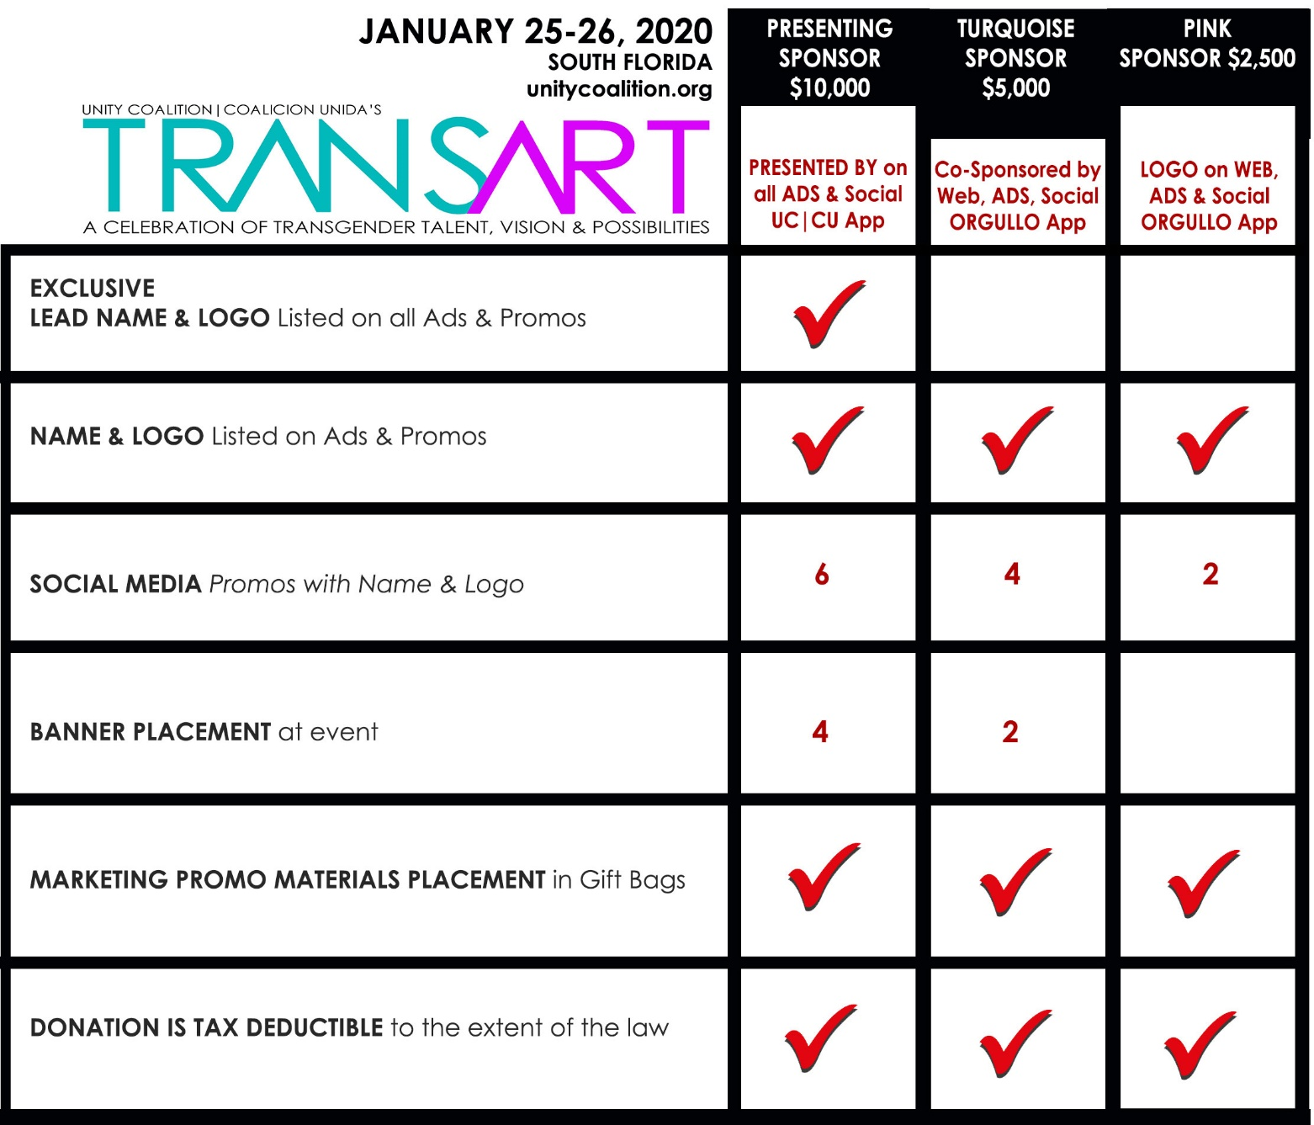

www.unitycoalition.org

