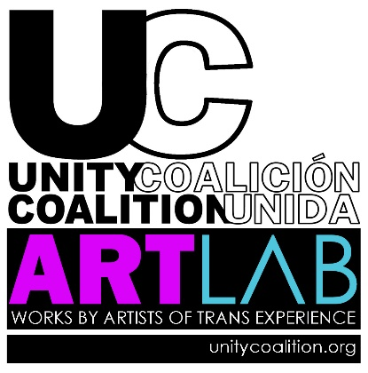
2025 ARTISTS APPLICATION
We are thrilled that you are considering being a part of
Unity Coalition|Coalición Unida’s TRANSART & ARTLAB

Artists & their work are considered throughout the year, and ArtLab is a virtual Artists Lab & “Brick and Mortar” Exhibit Space.

CHOSEN OR LEGAL NAME:
ARTISTS NAME (if different): What is your GENDER IDENTITY? _____________________
ADDRESS: Do you identify under the TRANS UMBRELLA? □ YES □ NO
CITY, STATE, ZIP, Country:
PHONE NUMBER: E-MAIL:
□ VISUAL ARTIST □ SCULPTOR/JEWELRY DESIGNER □ WRITER/AUTHOR/POET □ MUSICIAN □ DANCER/CHOREOGRAPHER □ FASHION DESIGNER □ CINEMATOGRAPHER □ GASTRONOMY □ OTHER
Describe your art/talent: ________________________________________________________________________________
________________________________________________________________________________________________________
________________________________________________________________________________________________________
________________________________________________________________________________________________________
________________________________________________________________________________________________________
________________________________________________________________________________________________________
________________________________________________________________________________________________________
________________________________________________________________________________________________________

□ Website/Social Media Handles (with examples of your work): .
□ ATTACH up to 12 hi-res JPGS or mail Color Photos & INCLUDE DIMENSIONS of the SPECIFIC PIECES you want to be considered for the show.
□ If you wish to offer your work for SALE, include price points. TRANSART respectfully requests 40% of sale to
be donated to UnityCoalition|Coalición Unida.
□ This is a Juried Show. ALL production, digital imagery & insurance costs must be covered by ARTIST.

Are you willing to be a part of a Virtual Artists Reception for your work? □ YES □ NO

Please describe how you identify with the Transgender/Gender non-conforming, Lesbian, Gay, Bisexual or Queer community: _____________________________________________________________________________________
________________________________________________________________________________________________________

UNITY COALITION|COALICIÓN UNIDA is the organization for the So. Fla. Latinx|Hispanic, Indigenous & of color LGBTQI+ communities - advancing Equality & Fairness - through Education, Leadership and Awareness, since 2002 – offering tools and programming, like ELEVATE- a day of workshops, tools & inspiration for being Nicer; The MicroGiving Incubator Fund, providing funding & mentorship for education and start-ups. Our annual TRANSART series – showcasing transgender and non-binary art & artists; CAŌBA, a Social Incubator for same gender loving people of color; and the annual Celebrate ORGULLO Hispanic & Indigenous Pride festival, and various other workshops, services & empowerment for the community.

SEND COMPLETED APPLICATION TO: herbsosa@yahoo.com or
MAIL TO: Unity Coalition|Coalición Unida 831 Ninth Street, Miami Beach, Florida 33139

www.unitycoalition.org 786-271-6982

